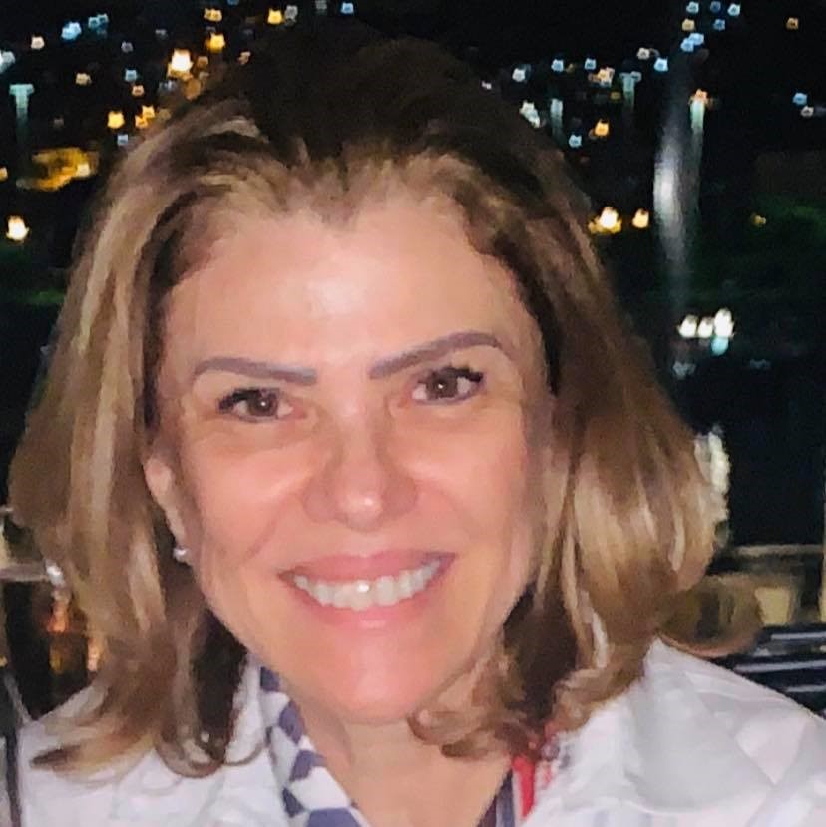 | FÁTIMA BAYMA DE OLIVEIRA  Short CV  Complete version (Lattes): http://lattes.cnpq.br/4031770197674534

1. PERSONAL IDENTIFICATION

Name: Fátima Bayma de Oliveira
Telephone: 55 (21) 3083-2707/2708
Cell Phone: 55 (21) 99914-3002
E-mail: fatima.oliveira@fgv.br

2. SUMMARY

Full professor at the Brazilian School of Public and Business Administration of the Fundação Getulio Vargas – FGV EBAPE (Rio de Janeiro, Brazil), and member of the Council on Education of the State of Rio de Janeiro. Primary research focus on education policies and leadership. Executive Secretary of the Worker Protection Fund Board (CODEFAT) (1999-2003) and Director of Jobs and Wages at Brazil’s Ministry of Labor and Employment (1999-2002). Ph.D. in Education from the Federal University of Rio de Janeiro – UFRJ (obtained in 1994) and a master’s degree from the University of Connecticut (USA) (obtained in 1980).

3. ACADEMIC EXPERIENCE

- Full professor on Ph.D., master and non degree programs , undergraduate in administration of the Brazilian School of Public and Business Administration EBAPE- FGV.
- Created and coordinated graduate- non degree programs at Fundação Getulio Vargas (FGV), in the fields of human resources, projects, financial management, marketing, and technologies in education (1980-1990).
- Adviser for numerous final papers, master’s thesis, and Ph.D. dissertations.
- Member of master’s thesis and Ph.D. dissertation defense committees in Brazil and abroad.
- Member of committees to select professors for public and private universities.

4. PROFESSIONAL EXPERIENCE

- Member of the Council on Education of the State of Rio de Janeiro (Brazil) – 2017 to current.
- Member of Diversity and Inclusion Committee of the Council on Education of the State of Rio de Janeiro (Brazil).
- Member of the Research Ethics Committee of the National Cancer Institute – INCA (Brazilian Ministry of Health) – 2003 to 2006.
- Member of the Fiscal Committee of the Brazilian Development Bank (BNDES) – 1999 to 2003.
- Director of Jobs and Wages at Brazil’s Ministry of Labor and Employment – 1999 to 2002.

5. BOOKS, BOOK CHAPTERS, ARTICLES

- Recent book chapters published abroad

- Rubin, M., Oliveira, F.B. & Nicholson, W.M. (2020). Racial Equity in Brazil. In S. Gooden (Ed.), Global Equity in Administration (pp. 135-156). New York, NY: Routledge.

- Pires, M. A. ; Silva, L. M. C. E. ; Oliveira, F. B. ; Santanna, A. S.(2019). Adaptation of the extended model of moral outrage in corporate social irresponsibility. In: Stehr, C.; Dziatzko, N.; Struve, F. (Org.). Corporate social responsibility in Brazil: the future is now (pp.191-219). 1ed.Cham, Switzerland: Springer International Publishing.

- Overview of books, book chapters, articles published in Brazil

- 05 books in the areas of health and social security management during the period from 2001 to 2015.

- Pós-Graduação e Mercado de Trabalho [Post-Degree and Labor Market]. Campinas: Editora Papirus , 1997.

- Ética e Educação – O Pensamento de Newton Sucupira [Ethics and Education – The Thinking of Newton Sucupira]. Rio de Janeiro: Editora Fundação Cesgranrio,1996.

- Articles published in leading specialized journals such as Brazilian Journal of Public Administration and Cadernos EBAPE.BR (FGV), and Revista Ensaio (Fundação Cesgranrio).

6. PARTICIPATION IN NATIONAL AND INTERNATIONAL LECTURES AND CONFERENCES

Participation in numerous events in the areas of education and leadership.

- Research presented in conferences

- PIRES, M. A.; OLIVEIRA, F. B.; SILVA, L. M. C. E.; SANT’ANNA, A. S.; OLIVEIRA, J. A. P. Moral outrage and social corporate irresponsibility: the ‘Fundão’ case. In: XXXVI European Group of Organizational Studies Colloquium - EGOS, 2020. XXXVI European Group of Organizational Studies Colloquium EGOS. Hamburg: EGOS, 2020.

- SANT'ANNA, A. S.; OLIVEIRA, F. B.; DINIZ, D. M. Inside out leadership: developing leaders for innovative ambiences. In: XLIV Encontro da Associação Nacional de Pós-graduação e Pesquisa em Administração – EnANPAD, 2020 [Meeting of the Brazilian National Association of Post-Degree and Research in Administration], Porto Alegre. XLIV Encontro da Associação Nacional de Pós-graduação e Pesquisa em Administração, EnANPAD. Porto Alegre: ANPAD, 2020.

- MILTERSTEINER, R. K.; OLIVEIRA, F. B.; SANT’ANNA, A. S. Female leadership development and practice: perceptions, reflections, and challenges in public administration. In: 80th Annual Meeting of the Academy of Management – AOM 2020, 2020, Vancouver. 80th Annual Meeting of the Academy of Management – AOM 2020. Vancouver: AOM, 2020.

- DAVILA, P. R.; OLIVEIRA, F. B.; DINIZ, D. M.; SANT'ANNA, A. S. Papeis e estilos de liderança em missão da ONU no Haiti: o que pensam as lideranças do exército brasileiro?. In: VII Encontro de Gestão de Pessoas e Relações de Trabalho – EnGPR, 2020, [Meeting on People Management and Relationships at Work] São Paulo. VII Encontro de Gestão de Pessoas e Relações de Trabalho – EnGPR. São Paulo: ANPAD, 2020.

- OLIVEIRA, F. B.; SANT’ANNA, A. S.; DINIZ, D. M.; CASTRO, D. C. Leadership in dynamics of socio-spatial qualification: the case of the case of the Port Region of Rio de Janeiro (Brazil). In: International Research Society for Public Management Annual Conference, 2019, Wellington, New Zealand. International Research Society for Public Management Annual Conference. Wellington, New Zealand: IRSPM, 2019.

- CARVALHO NETO, A. M.; SANT’ANNA, A. S.; DINIZ, D. M.; OLIVEIRA, F. B. Samba, troika, bhangra, a cross-cultural study into BRIC countries. In: European Academy of Management Annual Meeting - EURAM, 2019, Lisbon. European Academy of Management Annual Meeting - EURAM, 2019.

- SANT’ANNA, A. S.; OLIVEIRA, F. B. The revolution 4.0: a multilevel panorama. In: 79th Academy of Management Annual Meeting, 2019, Boston, MA. 79th Academy of Management Annual Meeting. Boston, MA: AoM, 2019.

7. MEMBER OF EDITORIAL BOARDS AND PARTICIPATION AS REVIEWER

- Leading member of the Encontro Nacional de Escolas de Administração [National Meeting of Schools of Administration] – ENANPAD – area of public administration – 2019.
- Member of the Scientific Committee of the journal Cadernos EBAPE.BR (FGV) – 2016-2019.
- Member of the Scientific Committee of Editora Access, Rio de Janeiro, 2019.
- Reviewer for numerous Brazilian journals

8. PARTICIPATION IN RESEARCH GROUPS (last 03 years)

- Research group on leadership in the public and private sectors, with professors from Fundação Dom Cabral and the Pontifical Catholic University of Minas Gerais.
- Research group of the War College on military and civil leadership.
- Research group on female leadership in the region of Porto Maravilha (Rio de Janeiro, Brazil), with professors from Fundação Dom Cabral and the Pontifical Catholic University of Minas Gerais.

9. LANGUAGES

- English, Spanish, and French (good understanding, reading, and speaking. Intermediate level of writing proficiency).

Last updated on September 22, 2020

