CALL FOR CHAPTERS
Unraveling the Tapestry of Traditional, Relational and Multicultural Feminist Mentoring Frameworks
Editors: Dr. Rajashi Ghosh and Dr. Payal Kumar

This Handbook on Mentoring Frameworks is a part of the Handbook of Diversity, Equity and Inclusion in Management - World Scientific Publishers. This is a 5-volume, multi-disciplinary, comprehensive reference work, led by global domain experts. As Volume 1, this Handbook on Mentoring Frameworks will consist of about 22 peer-reviewed chapters (7,000-7,500 words including References), with each contribution expected to add new knowledge to the literature. Furthermore, this volume will end with a Teaching and Learning Section, to summarize how the research in the field can impact teaching in the classroom.
Key dates:
30th April, 2024 – 750 words Abstract submission (email rajashi.ghosh@tc.columbia.edu)
15th May, 2024: Response from editors
15th January, 2025: Final submission for peer review
Theoretical frameworks prevalent in the Western mentoring literature largely include two perspectives. First, there is the notion of traditional mentoring according to which mentoring is a dyadic, hierarchical relationship where the mentor by the virtue of being more experienced offers career and psychosocial support to their mentees (Kram, 1983). “The inherent power dynamics in traditional mentoring relationships reinforce the notion that learning flows from above, with mentors passing down valuable information and insights” (Zhang, et al., 2023, p. 644). Second, we can refer to the concept of relational mentoring (Ragins, 2012), which is bi-directional, mutual, interdependent, generative and a developmental relationship that benefits both the mentor and the mentee. Many organizations continue to follow the first framework, in which the mentoring relationship is hierarchical, dyadic and one-directional (from mentor to protégé). Few organizations follow the second framework of relational mentoring, in which the relationship is more bi-directional (benefitting both mentor and protégé). While relational mentoring expands the value of mentoring for the mentors, sustaining relational mentoring connections is challenging as both the mentor and protégé need to spend time learning about each other’s needs, and also be vulnerable enough to have fair and open communication (Ghosh, 2015; Ghosh et al., 2020).
Since the traditional mentoring framework, there has been a shift from employer-focused mentoring, where the firm pairs the mentor and protégé, to a more protégé-led process in which the onus is seen to be on the protégé to develop a relationship constellation, also known as developmental networks consisting not only of formal mentors at the firm, but also informal mentors who may or not be part of the firm (Higgins & Kram, 2001). These developmental networks can include a mix of traditional and relational mentors (formal and informal) as this enables the mentees to appreciate the value that different types of mentors can offer.
However, there are still many assumptions and questions that remain:
- Forming a developmental network assumes a level playing field for all employees. However, it likely to be more challenging for – say a woman of color – to find mentors that would accept her in a self-initiated mentoring relationship.
- Since the mentor is likely to be male and the protégé female in many industries, the traditional, hierarchical framework is perpetuated in a gendered way without making space for women to engage mutually with their mentors.
- The traditional, hierarchical framework may also be perpetuated by a mimicking of dysfunctional gendered relationships at home e.g., one study suggests that male mentors at times treated female mentees like daughters, and males like sons (Williams et al., 2014), to the detriment of women’s equality.
This book examines Traditional and Relational mentoring frameworks and incorporates a third framework which is fairly new in the literature, namely Multicultural Feminist mentoring. Feminist perspectives (Benishek et al., 2004) advocate for an explicit concern for one’s holistic growth and well-being at the intersections of work and family lives. Multicultural feminist mentoring goes a step further to recommend that feminist mentors with multicultural competence must tailor the relationship to meet the unique needs of diverse mentees (Chan et al., 2015). Feminist multicultural mentors aim not to replicate the power inequalities perpetuated in traditional mentoring models that can marginalize woman mentees, but rather practice sharing their power by ensuring that their mentees have a voice in the relationship to contribute towards systemic change.
Furthermore, the goals of feminist mentoring are more focused on structural change than personal success (DeMarco, 1993). So instead of “fixing” women, this mentoring helps identify barriers to women’s success at work at the organization and beyond (Ong et al., 2018). Also, feminist mentoring can help to provide safe spaces where underrepresented groups can come together for support, not only for women, but also for those with others with identities that are historically marginalized.
We contend that the Traditional, Relational, and Multicultural Feminist mentoring frameworks are not as exclusive as they might appear. Whether one follows either of these frameworks or some combination of these frameworks will depend on the moderating conditions of organizational culture, national cultural preferences, individual characteristics, and relational dynamics. Moreover, over time, a traditional relationship can evolve into a relational and/or a multicultural feminist one and the directionality of such evolution is again likely to be influenced by the cultural context. Given this, we are interested to explore how these different frameworks interact with individual, organizational, national, and other contextual factors to influence experiences of mentoring relationships across the globe.
In this call for chapters here are indicative themes and questions (not an exhaustive list) to be explored: -
Mentoring Frameworks & different Industry/Organization culture:
- What is the relationship between these mentoring frameworks and organizational cultures and what moderating conditions shape that relationship?
- Which mentoring framework is more suitable for different industries?
- Practicing feminist mentoring may not be appreciated as a legitimate work activity by the organization and thus those engaged in this may not receive the due credit for this (Dashper, 2017). How does one ensure that this does not discourage such mentors?
- How can these different Mentoring frameworks be used in Human resource Development (HRD) initiatives in different global organizations (Ghosh & Hutchins, 2023)?

Mentoring Frameworks & Diversity:
- Which mentoring framework is more suitable for different generations of protégés?
- Which mentoring framework is more aligned/not aligned with different national/regional cultural preferences?
- Multicultural feminism raises the question of privilege and the complexities of the intersectionality of race, class, gender and even the caste system (Kumar, 2018). How far can the mentor and protégé navigate such complexities?

Mentoring Frameworks & Outcomes and Antecedents:
- How do these three frameworks compare in terms of mentoring outcomes such as job satisfaction, growth, productivity, well-being, psychological safety etc.?
- What are the benefits and drawbacks of implementing each of the frameworks?
- What are the traits of an effective mentor and effective protégé as per these frameworks? Can these frameworks help to identify how mentors can perpetuate toxic cultures in organizations (Ghosh & Chaudhuri, 2022)?
- How important is it for leadership to be a committed ally to multicultural feminist mentoring?

Mentoring Frameworks & Teaching and Learning:
- Which of these mentoring frameworks can best facilitate learning for both mentees and mentors? Why?
- How do the adult learning theoretical perspectives speak to the different mentoring frameworks?
- Can mentors and protégés be trained to model these mentoring frameworks? How?
- What kinds of teaching tools can best illustrate these different mentoring frameworks?

References

Benishek, L. A., Bieschke, K. J., Park, J., & Slattery, S. M. (2004). A multicultural feminist model of mentoring. Journal of Multicultural Counseling and Development, 32, 428-442.

Chan, A. W., Yeh, C. J., & Krumboltz, J. D. (2015). Mentoring ethnic minority counseling and clinical psychology students: A multicultural, ecological, and relational model. Journal of Counseling Psychology, 62(4), 592-607.

Dashper, K. (2017). Confident, focused and connected: The importance of mentoring for women’s career development in the events industry. Journal of Policy Research in Tourism, Leisure and Events, 10(2), 134150.

DeMarco, R. (1993). Mentorship: a feminist critique of current research. Journal of Advanced Nursing, 18(8), 1242-1250.

Ghosh, R. (2015). Mentoring–Is it failing women?. New Horizons in Adult Education and Human Resource Development, 27(4), 70-74.

Ghosh, R., & Chaudhuri, S. S. (2022). Are Mentors Modeling Toxic' Ideal Worker' Norms?. MIT Sloan Management Review, 64(1), 1-4.

Ghosh, R. and Hutchins, H.M. (2023). HRD perspectives on developmental relationships: Connecting and relating at work. Basingstoke: Palgrave Macmillan.

Ghosh, R., Hutchins, H. M., Rose, K. J., & Manongsong, A. M. (2020). Exploring the lived experiences of mutuality in diverse formal faculty mentoring partnerships through the lens of mentoring schemas. Human Resource Development Quarterly, 31(3), 319-340.

Higgins, M. C., & Kram, K. E. (2001). Reconceptualizing mentoring at work: A developmental network perspective. Academy of management review, 26(2), 264-288.

Kram, K.E. (1983).Phases of the mentor relationship. Academy of Management Journal, 26, 608–625.

Kumar, P. (2018). Exploring incongruence in mentoring dyads in Indian firms: The protégé perspective. South Asian Journal of Human Resources Management, 5(2), 216-233.

Ong, M., Smith, J. M., & Ko, L. T. (2018). Counter spaces for women of color in STEM higher education: Marginal and central spaces for persistence and success. Journal of research in science teaching, 55(2), 206-245.

Ragins BR. (2012). Relational mentoring: A positive approach to mentoring at work. In K Cameron, G Spreitzer (Eds.), The handbook of positive organizational scholarship (pp. 519–536). New York, NY: Oxford University.

Williams, C. L., Kilanski, K., & Muller, C. (2014). Corporate diversity programs and gender inequality in the oil and gas industry. Work and Occupations, 41(4), 440-476.

Zhang, T., Wang, D. J., & Galinsky, A. D. (2023). Learning down to train up: mentors are more effective when they value insights from below. Academy of Management Journal, 66(2), 604-637.

Dr. Rajashi Ghosh
(Email: rajashi.ghosh@tc.columbia.edu)

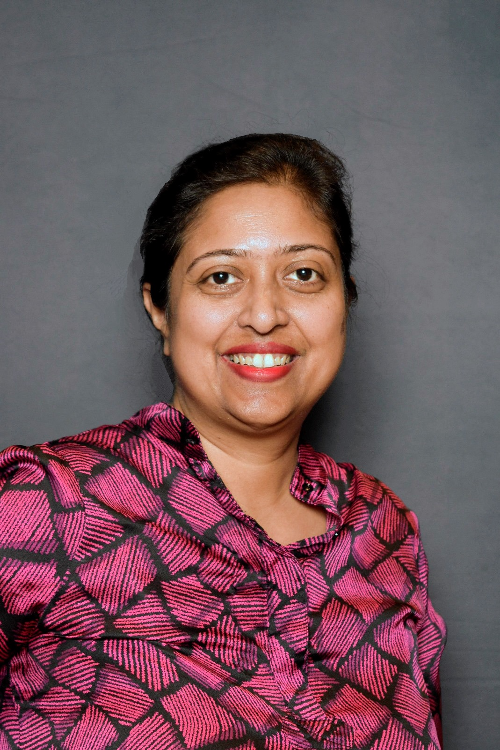

Dr. Ghosh is currently an Associate Professor of Adult Learning & Leadership (ALL) in the Department of Organization & Leadership in Teachers College, Columbia University. Her background is in adult learning and development. She teaches, publishes, and conducts research to promote continuous learning and development of adults in workplaces. Her research aims to explore how different developmental initiatives (e.g., mentoring, coaching, leadership development) can facilitate workplace learning and development through building inclusive relational spaces and countering the prevalence of workplace incivility. Dr. Ghosh’s work is inter-disciplinary, as evidenced by the different awards she has received.

Specifically, her dissertation was recognized by the 2010 Dissertation of the Year Award from the Workplace Learning Special Interest Group (SIG) of American Educational Research Association (AERA) and her work applying adult development theory to leader development and mentoring was honored by the 2010 Best Paper Award in Management Education and Development division of Academy of Management (AOM). More recently, Dr. Ghosh has been recognized by the 2016 Early Career Scholar Award at the Academy of Human Resource Development (AHRD), the 2015-16 Award for Outstanding Early Career Scholar Achievement from the Office of Provost at Drexel University, the 2018-19 Provost Fellowship at Drexel University, the 2020 Drexel Solutions Institute Fellowship with the Office of Provost, 2022 Mid-career Research Award from Drexel School of Education (SoE), the 2021 National Science Foundation (NSF) Mid-Career Award (MCA) grant, and the 2022 AHRD Wayne Pace Book of the Year Award for her recently co-edited book, Connecting and Relating at Work: HRD Perspectives on Developmental Relationships.

Google scholar link: https://scholar.google.com/citations?user=v81Jj4YAAAAJ&hl=en&oi=ao

Dr. Payal Kumar
(Email: payalk1@gmail.com)

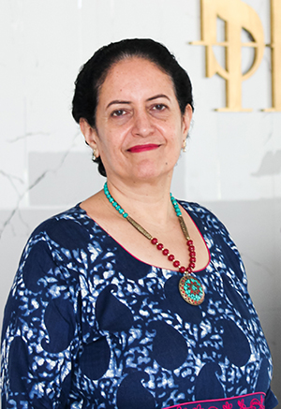

Dr. Payal Kumar is Principal Academic Advisor, Indian School of Hospitality, India. She completed her Master of Arts from the School of Oriental and African Studies, UK, and Ph.D from XLRI, India. Dr Kumar is a board member of several prestigious journals and is a reviewer journals for top journals such as Academy of Management Review, AMLE and Journal of Organizational Behaviour. She has published several papers and also 18 books with Palgrave Macmillan, Springer and Emerald Publishers. Not only is she a prolific writer, but she is also a prize-winning researcher, with accolades including the Andre Delbecq & Lee Robbins MSR Scholarship, 2019 (Academy of Management, USA) and the best-symposium prize at the Academy of Management Conference, Seattle, 2022. Her research interests include diversity, equity and inclusion; leadership and followership; sustainability, business ethics and also research from an Indian-centric perspective. She is also Global L&D advisor to MamimizeU, USA. In an earlier avatar, Payal was Vice President Editorial and Production, SAGE Publications Ltd.

https://www.linkedin.com/in/payalk1/
https://www.facebook.com/payal.kumar.186
twitter: @payalk1

Handbook co-editors are Professors Payal Kumar and Pawan Budhwar

